# CS 305 Module Five Coding Assignment Checksum Verification Template

## Algorithm Cipher

Provide a recommendation for an appropriate collision-free encryption algorithm.

Due to its low collision probability, the SHA256 algorithm will be my choice.

## Justification

Legitimize your thinking for the suggested calculation figure by giving a short, significant-level outline of the encryption calculation figure.

The Public Safety Office created SHA-256 in 2001 as a substitution for SHA-1.

Furthermore, SHA-256 is one of the most solid hashing capabilities available, as the calculation has a 0.01% likelihood of crashes. When an algorithm generates the same hash value for two distinct pieces of data, this is known as a collision. Characters with lowercase letters or numbers from 0 to 9 are output by SHA256. With 3664 possible outcomes, it is highly unlikely that two pieces of data would collide or have the same hash value. (N-able, 2019)

## Generate Checksum

To verify the code, refactor it to encrypt a text string and generate a checksum. You will present your refactored code for your educator to audit notwithstanding this archive.

## Verification

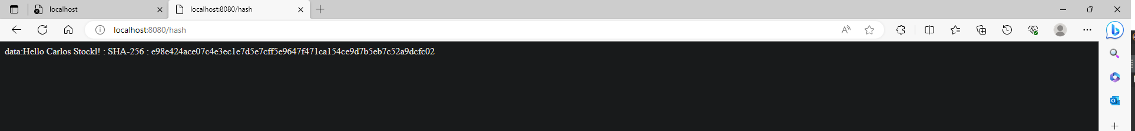

Reference:

N-able. (2021, April 1). *SHA-256 algorithm - N-able*. N. https://www.n-able.com/blog/sha-256-encryption